Task 2: Website Feedback
During the investigation of the provided Danske Bank website (https://job.danskebank.lt/jobs/), 10 bugs (input validation issues, UI issues) were found and potential improvements and suggestions were noted.
UI and input validation issues:
- “Back” button works exactly as the browser’s back button
Steps to reproduce: Navigate to https://job.danskebank.lt/jobs/ > click “All the advantages” page > click “The reason why” page > press “Back” button 
Actual result: User gets returned to the previous page.
Suggestion for improvement: For better user experience, back button should return straight to the positions page.
- Dropdowns change style after selecting an option
Steps to reproduce: Navigate to https://job.danskebank.lt/jobs/ > click on the filter dropdown (e.g., )> choose any option from the dropdown
Actual result: filters style changes
Expected result: filters style does not change.
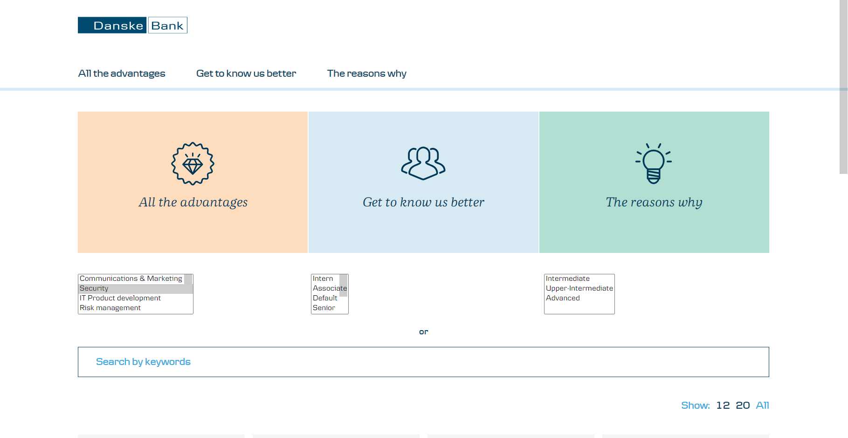
- Pagination disappears after clicking logo
Steps to reproduce: Navigate to https://job.danskebank.lt/jobs/ > click on the logo icon on the top left
Actual result: pagination and page size disappear
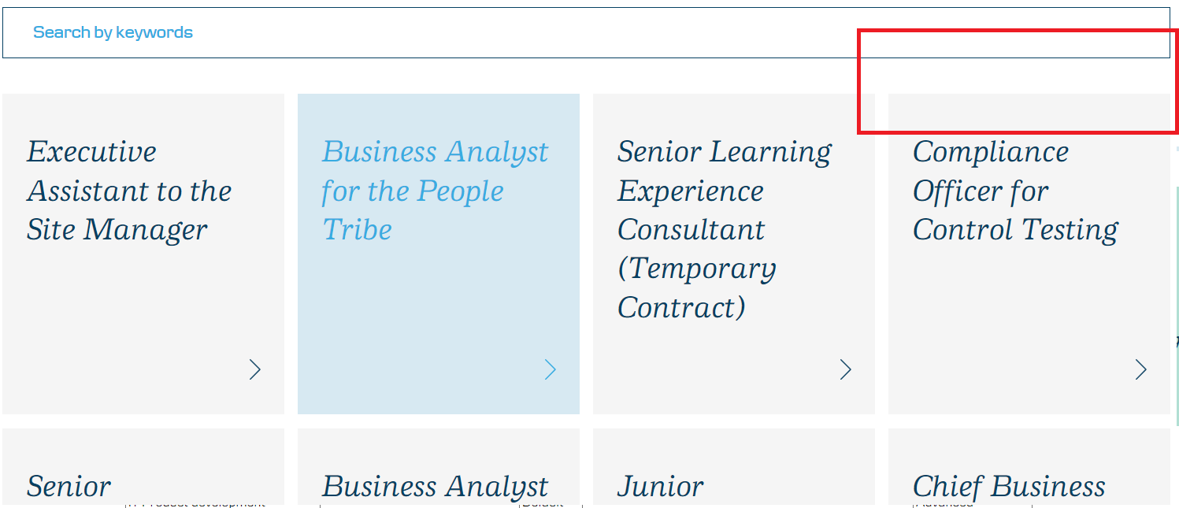
Expected result: pagination and page size are still present
- 3 clickable pages (“All the advantages”,” Get to know us better”,” The reasons why”) disappear after pressing back button
Steps to reproduce: Navigate to https://job.danskebank.lt/jobs/ > Go to DevTools and switch to phone mode (press Toggle Device toolbar)> click on any open position> click “Back” button
Actual result: “All the advantages”,” Get to know us better”,” The reasons why” pages disappear
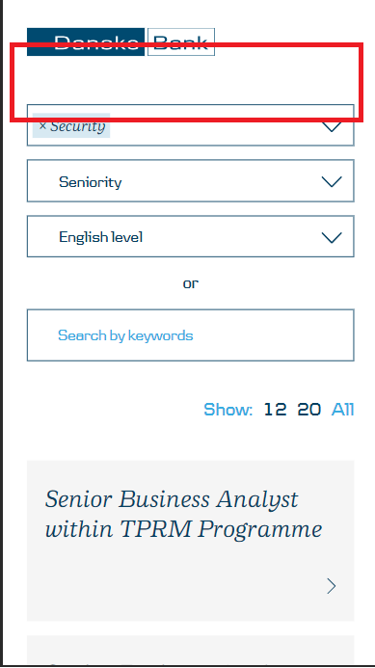
Expected result: Pages are still visible.
- When pressing "clear all" in dropdown, it opens for a moment
Steps to reproduce: Navigate to https://job.danskebank.lt/jobs/ > click on any dropdown and choose an option> click “Clear all” button
Actual result: dropdown opens and page refreshes
Expected result: “clear all” button does not trigger dropdown to open.
- # & + symbols disappear from search field after pressing Enter
Steps to reproduce: Navigate to https://job.danskebank.lt/jobs/ > click on the search field> type #, & or + symbol> press “Enter”
Actual result: page refreshes and search field become empty
Expected result: Symbol is still present in the search fields.
- After clicking second time in the dropdown while typing, it closes and text disappears
Steps to reproduce: Navigate to https://job.danskebank.lt/jobs/ > click on any dropdown and star typing> click on the dropdown again
Actual result: dropdown closes and text disappear
Expected result: dropdown field is in focus and text is present.
- typing ‘ " ’ and ‘ \ ’ symbol in search field and pressing Enter causes ‘ \ ’ symbol to appear
Steps to reproduce: Navigate to https://job.danskebank.lt/jobs/ > click on the search field and type ‘ ” ’ or ‘ \ ’ symbol> press Enter
Actual result: another ‘ \ ’ symbol appears in the search field
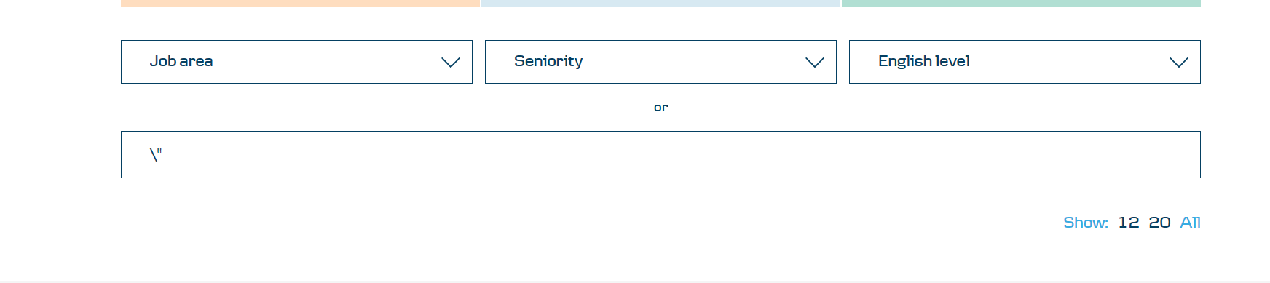
Expected result: no additional symbols appear in the search field.
- “ < “ symbol converts into character entity "&lt;" in the search field after pressing Enter
Steps to reproduce: Navigate to https://job.danskebank.lt/jobs/ > click on the search field and type “ < “ symbol> press Enter
Actual result: "&lt;" text appears instead of “ < “ symbol
Expected result: “ < “ symbol do not change
- Phone icon in the bottom is visible even without a phone number
Steps to reproduce: Navigate to https://job.danskebank.lt/jobs/ > click on the search field and type “compensation squad”> navigate to the given result > scroll down to the end of the page
Actual result: phone icon is visible without a phone number
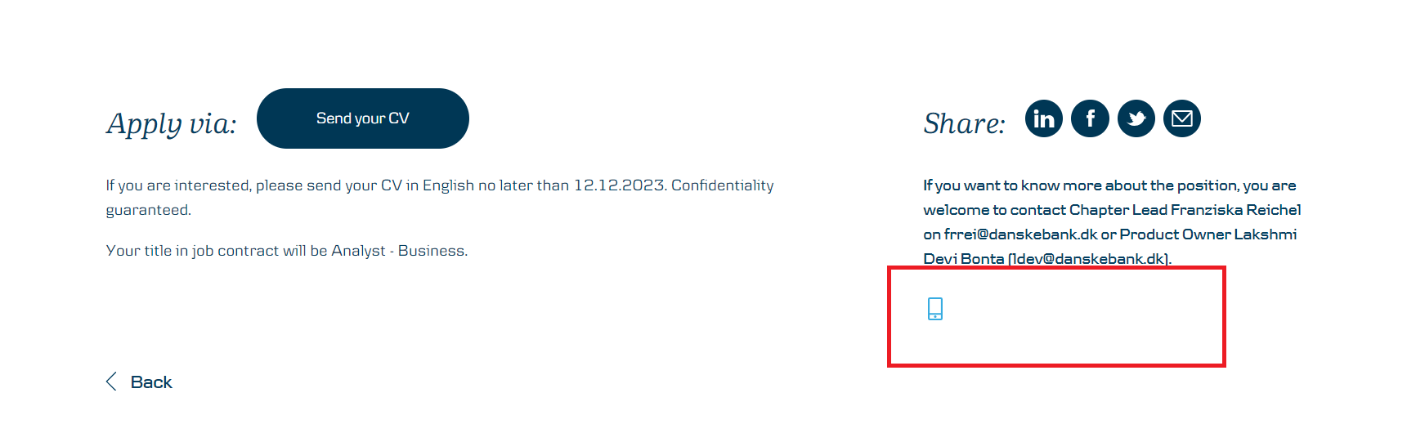
Expected result: phone icon is not present
Improvements:
- No "no results" text on the main page
It would be more user friendly if there is “No results” text after certain search request instead of blank page
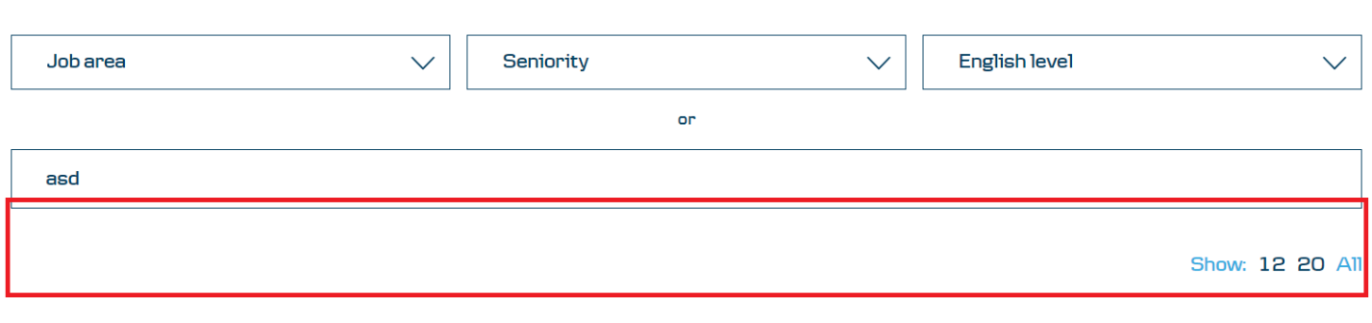
- 3 clickable pages are duplicated with fonts and icons
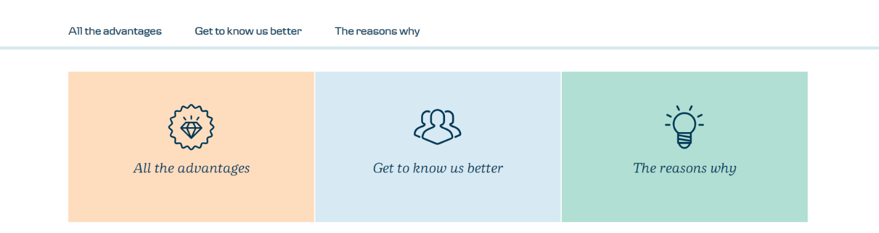
It’s confusing to duplicate the same pages on one page. It’s more user-friendly to add font and icons to the top links and remove duplicated ones.
- Add search button or apply search filter after typing 3 symbols
It is more user-friendly to add search button or add automatic search functionality after you type 3 symbols, because at first it is confusing.

